
UNIVERSITY OF
BUEA

FACULTY OF
ENGINEERING AND
TECHNOLOGY
(FET)

REPUBLIC OF
CAMEROON

PEACE-WORK-FATHERLAND

PROJECT TITTLE
TASK 6 REPORT
Backend Implementation and Database Development
for CrowdSenseNet

Crowdsensed Mobile Network Coverage Analysis System
COURSE TITLE: INTERNET PROGRAMMING AND MOBILE
PROGRAMMING
COURSE CODE: CEF 440
COURSE INSTRUCTOR: Dr. Nkameni Valery

ACADEMIC YEAR 2025 - 2026

Project Group: Group 13
Submitted by:
1. Imele Azafa Jose de Kajos ………………………… FE23A068
2. Ayuk Amelia Agbor Orock ………..……………… FE23A020
3. Ngome Fernandez Manyaka ……….……………… FE23A111
4. Tadjeu Ngnintedem Aubry-Junex …….…………… FE23A148
5. Bessong Takang Tabot Willy …………………..…… FE23A025

Table of Contents
Table of Contents 2
1. Introduction 6
2. Data Elements Analysis 8
2.1 Device Data 8
2.2 Session Data 8
2.3 Signal Reading Data 8
2.4 Location Data 9
2.5 Synchronisation Data 9
2.6 Coverage Analysis Data 9
3. Conceptual Design 14
3.1 Actors 14
3.2 Main System Components 14
3.3 Data Flow 15
3.4 Backend and Server Responsibilities 15
3.5 Database Responsibilities 15
4. Entity Relationship Diagram Design 17
4.1 Device Entity 17
Purpose 17
Main Attributes 17
Relationships 18
4.2 Session Entity 18
Purpose 18
Main Attributes 18
Relationships 18
4.3 SignalReading Entity 19
Purpose 19
Main Attributes 19
Relationships 19
4.4 Location Entity 20
Purpose 20
Main Attributes 20
Relationships 20
4.5 CellTower Entity 20
Purpose 20
Main Attributes 20
Relationships 21
4.6 AppSettings Entity 21
Purpose 21
Main Attributes 21
Relationships 21
4.7 ExportFile Entity 22
Purpose 22
Main Attributes 22
Relationships 22
4.8 ServerUpload Entity 22
Purpose 22
Main Attributes 22
Relationships 23
4.9 CoverageZone Entity 23
Purpose 23
Main Attributes 23
Relationships 24
4.10 ZoneReading Associative Entity 24
Purpose 24
Main Attributes 24
4.11 Admin Entity 24
Purpose 24
Main Attributes 24
Relationships 25
4.12 AnalysisReport Entity 25
Purpose 25
Main Attributes 25
Relationships 26
4.13 Relationship Cardinalities and Database Normalisation 26
5. Backend Implementation 28
5.1 Backend Architecture 28
Client-Server Architecture 28
REST API Design 28
Request and Response Flow 28
5.2 API Design 28
Session APIs 29
Signal Reading APIs 29
Coverage Analysis APIs 29
Export APIs 29
5.3 Business Logic Layer 30
Data Validation 30
Coverage Classification 30
Report Generation 31
Export Generation 31
5.4 Security Measures 31
Anonymous Device Identification 31
Authentication and Authorisation 31
Data Validation and Input Sanitisation 31
6. Database Implementation 33
6.1 Database Technology Selection 33
6.2 Database Schema Implementation 33
6.3 Constraints 35
Primary Keys 35
Foreign Keys 35
Unique Constraints 35
Not Null Constraints 35
6.4 Indexing Strategy 35
7. Connecting the Database to the Backend 37
7.1 Database Connection Configuration 37
7.2 Repository Layer 37
7.3 CRUD Operations 37
7.4 Data Synchronisation Process 38
7.5 Error Handling 38
7.6 Performance Considerations 39
8. Testing and Validation 40
8.1 API Testing 40
8.2 Database Testing 40
8.3 Integration Testing 40
8.4 Data Validation Testing 41
9. Conclusion 42
References 44

1. Introduction
CrowdSenseNet is a crowdsensed mobile network coverage analysis system. The application is designed to enable ordinary citizens to passively contribute mobile signal measurements, including LTE signal strength, GPS coordinates, and session metadata, while carrying their smartphones in everyday life. These measurements are aggregated anonymously to produce a real-time, crowd-sourced coverage heatmap accessible to the public.
Task 6 represents a critical milestone in the development of CrowdSenseNet. It encompasses the definition and analysis of all data elements used by the system, the design of a comprehensive Entity Relationship Diagram (ERD), the physical implementation of the database, the development of the backend server, and the integration of the database with the backend services. Together, these components form the technical backbone that transforms the CrowdSenseNet Android application from a standalone data collection tool into a fully connected, server-side system capable of processing and serving mobile coverage information at scale.
Backend development is essential in any modern mobile application. The frontend provides the user interface, but it is the backend that ensures data is properly received, validated, stored, processed, and made available for analysis. Without a well-designed backend, the application would function only as a local prototype with no means of aggregating data across multiple devices, performing server-side coverage analysis, or providing export capabilities for engineers and researchers.
The CrowdSenseNet backend serves several important purposes. It provides a set of REST API endpoints that the Android application communicates with to upload session data and signal readings. It implements a business logic layer that validates incoming data, classifies coverage zones based on collected signal strengths, and generates coverage analysis reports. It also implements security measures that protect user privacy through anonymous device identification and enforce proper authentication and authorisation controls.
Database design is equally important. A well-normalised database schema ensures that data is stored without redundancy, that referential integrity is maintained, and that queries can be executed efficiently even as the volume of readings grows. The CrowdSenseNet database was designed in compliance with Third Normal Form (3NF) and implemented using PostgreSQL, a robust open-source relational database management system well-suited to handling large datasets.
The relationship between the three core components of the system is illustrated in Figure 1.1 below. The Android application acts as the data collection layer, gathering signal readings and GPS coordinates from user devices. The backend server acts as the processing and routing layer, receiving uploads from the application, applying business logic, and storing results in the database. The database acts as the persistence layer, storing all device, session, signal reading, location, and coverage zone data in a structured and normalised form.
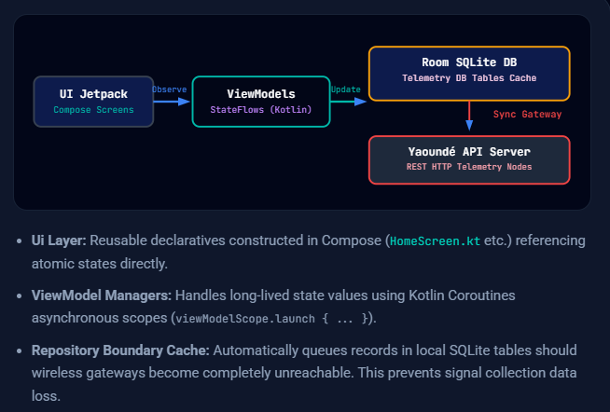
Figure 1.1: High-level architecture diagram showing the relationship between the Android application, backend server, and PostgreSQL database in the CrowdSenseNet system.

2. Data Elements Analysis
A data element is a fundamental unit of information that the system collects, stores, processes, or transmits. This section defines all 23 data elements used by CrowdSenseNet, grouped by category. These elements were identified through a systematic analysis of the application's data collection requirements, the Android APIs used to obtain them, and the storage and synchronisation needs of the system. This data elements dictionary serves as the authoritative reference for the database schema, API contracts, and data synchronisation logic throughout the project.
The data elements are organised into six major categories: Device Data, Session Data, Signal Reading Data, Location Data, Synchronisation Data, and Coverage Analysis Data. Each category is discussed in detail in the subsections below.

2.1 Device Data
Device data elements represent the identifying and descriptive information associated with each participating smartphone. CrowdSenseNet was designed with privacy by design principles, meaning that no personally identifiable information (PII) is collected from users at any point.
The Device ID is a UUID (Universally Unique Identifier) generated using Java's UUID.randomUUID() method on the first launch of the application. It is stored in Android SharedPreferences and persists across app restarts. Critically, it is not derived from any hardware identifier such as the IMEI or IMSI, ensuring that it cannot be linked to a specific individual or device at the hardware level. The Anonymous Token is a secondary identifier generated for authentication purposes, allowing the backend to verify that an upload originates from a registered device without requiring user credentials. The Device Model, Android Version, and Manufacturer fields are collected to support analysis of whether signal measurement quality varies by device type, which may have implications for data quality filtering on the server side.

2.2 Session Data
A session represents a bounded data collection event, beginning when the user presses the Start Sensing button and ending when the user presses Stop Sensing or when the application is closed. Each session is assigned a globally unique Session ID at the point of creation.
The Start Time and End Time are recorded as Unix epoch timestamps in milliseconds, obtained using System.currentTimeMillis(). The Duration is derived by subtracting the Start Time from the End Time and is stored in seconds for readability. The Reading Count is an integer that is incremented with each 3-second poll cycle during the session, providing a quick summary of session productivity. The Upload Status is an enumeration with values PENDING, UPLOADED, or FAILED, indicating the current synchronisation state of the session with the cloud backend.

2.3 Signal Reading Data
Signal reading data elements are the core measurements collected by CrowdSenseNet. They are obtained from the Android TelephonyManager API, specifically through the getAllCellInfo() method, which is polled every three seconds during an active session.
Reference Signal Received Power (RSRP) is the primary LTE signal strength indicator, expressed in dBm, and ranges from -140 dBm to -44 dBm. Higher values indicate a stronger signal. RSRP is the most important metric for coverage classification. Reference Signal Received Quality (RSRQ) is expressed in dB and ranges from -20 dB to -3 dB. It indicates the quality of the received reference signal relative to interference and noise. Signal-to-Interference-plus-Noise Ratio (SINR) ranges from -20 dB to +30 dB and provides a measure of the overall connection quality. Received Signal Strength Indicator (RSSI) ranges from -113 dBm to -51 dBm and represents the total received broadband power, including noise and interference from all sources. Each reading is also associated with a Timestamp, the Cell ID of the serving base station, and the Network Type indicating whether the device is on LTE, 3G, 2G, or 5G.

2.4 Location Data
Location data is collected simultaneously with signal readings using the Android LocationManager. All location data uses the WGS-84 coordinate reference system, which is the standard used by GPS satellites globally.
Latitude is stored as a DECIMAL(10,8) value, covering the range -90.0 to +90.0 degrees. Longitude is stored as a DECIMAL(11,8) value, covering the range -180.0 to +180.0 degrees. The Altitude field is a floating point value in metres above sea level, collected where the GPS fix is sufficient to provide it. The Accuracy field records the estimated horizontal accuracy radius of the current GPS fix in metres; typical consumer-grade GPS modules achieve accuracy within 3 to 10 metres under open-sky conditions.

2.5 Synchronisation Data
Synchronisation data elements track the process of uploading locally stored session data to the cloud backend. Because CrowdSenseNet operates in environments where internet connectivity may be intermittent, the system must maintain a clear record of the upload state of each session.
The Upload Status is the primary synchronisation indicator, with values PENDING (data not yet uploaded), UPLOADED (successfully synchronised to the server), or FAILED (an upload was attempted but unsuccessful). The Upload Timestamp records the exact date and time at which a successful upload was completed. The Server Response field stores the HTTP response body received from the backend server following an upload attempt, which may include confirmation details or error messages that assist in diagnosing upload failures.

2.6 Coverage Analysis Data
Coverage analysis data elements are derived from the raw signal readings and are used to produce the coverage heatmap displayed within the application and on the administrative dashboard.
Coverage Zones are geographical areas defined by grid references that group multiple signal readings together for aggregate analysis. The Coverage Classification is the most important derived element, assigning each zone one of four classes: GOOD COVERAGE, AVERAGE COVERAGE, COVERAGE HOLE, or INSUFFICIENT DATA. The Reading Count for a zone reflects the total number of signal readings that have been collected within its geographical boundaries. The Average Signal Strength represents the mean RSRP value across all readings in the zone and is the primary input for the coverage classification algorithm.
The following table summarises all 23 data elements used by CrowdSenseNet, including their data types, units, sources, valid ranges, and descriptions.

# | Element Name | Data Type | Unit | Source / API | Range / Values | Description
1 | RSRP | Float | dBm | TelephonyManager.getAllCellInfo() | -140 to -44 dBm | Reference Signal Received Power; the primary LTE signal strength indicator.
2 | RSRQ | Float | dB | TelephonyManager.getAllCellInfo() | -20 to -3 dB | Reference Signal Received Quality; signal quality relative to noise and interference.
3 | SINR | Float | dB | TelephonyManager.getAllCellInfo() | -20 to +30 dB | Signal-to-Interference-plus-Noise Ratio; overall LTE connection quality.
4 | RSSI | Float | dBm | TelephonyManager.getAllCellInfo() | -113 to -51 dBm | Received Signal Strength Indicator; total received broadband power.
5 | Cell ID | Integer | - | CellInfo.getCellIdentity() | 1 to 268,435,455 | Unique numeric identifier of the serving LTE base station.
6 | Network Type | String | - | TelephonyManager.getNetworkType() | LTE / 3G / 2G / 5G | Mobile network generation currently serving the device.
7 | Carrier Name | String | - | TelephonyManager.getNetworkOperatorName() | e.g. MTN Cameroon | Human-readable name of the active mobile network operator.
8 | Latitude | Double | degrees | Android LocationManager / GPS | -90.0 to +90.0 | WGS-84 geographic latitude of the measurement point.
9 | Longitude | Double | degrees | Android LocationManager / GPS | -180.0 to +180.0 | WGS-84 geographic longitude of the measurement point.
10 | GPS Accuracy | Float | m | Location.getAccuracy() | >=0 m (3-10 m typical) | Estimated horizontal accuracy radius of the current GPS fix in metres.
11 | GPS Status | Enum | - | LocationListener callbacks | ACTIVE / SEARCHING / DISABLED | Current GPS lock state on the device at time of reading.
12 | Session ID | UUID (String) | - | UUID.randomUUID() at session start | UUID v4 format | Globally unique identifier assigned to each sensing session.
13 | Device UUID | UUID (String) | - | SharedPreferences (generated once on first launch) | UUID v4 format | Anonymous, persistent device identifier with no personal data linked.
14 | Session Start Time | Long (ms) | ms | System.currentTimeMillis() at start | Unix epoch in ms | Timestamp when the user pressed Start Sensing.
15 | Session End Time | Long (ms) | ms | System.currentTimeMillis() at stop | Unix epoch in ms | Timestamp when the user pressed Stop Sensing.
16 | Session Duration | Long | s | Derived: End - Start | >=0 seconds | Total elapsed time of the sensing session in seconds.
17 | Reading Count | Integer | - | Incremented per 3-second poll cycle | >=0 | Total number of signal readings collected during the session.
18 | Upload Status | Enum | - | Room DB + background sync service | PENDING / UPLOADED / FAILED | Current synchronisation state of the session with the cloud backend.
19 | Coverage Class | Enum | - | Derived from RSRP value | GOOD / AVERAGE / HOLE / INSUFFICIENT | Signal quality classification used for heatmap colour rendering.
20 | Reading Density | Float | rdgs/km2 | Derived: count / area | >=0 | Spatial density of readings; values below 50/km2 are flagged INSUFFICIENT DATA.
21 | App Language | String | - | Android DataStore | en-US / fr-FR | User-selected UI language, stored persistently across app restarts.
22 | WiFi-Only Upload | Boolean | - | Android DataStore | true / false | When true, data is synchronised only on WiFi connections.
23 | Sampling Rate | Integer | Hz | Android DataStore | 1 Hz (default) | Frequency of signal readings per second; controls the TelephonyManager poll interval.

Table 2.1: CrowdSenseNet Data Elements Dictionary.
The coverage classification reference is provided in Table 2.2 below. The thresholds are based on industry-standard LTE signal quality benchmarks.

Coverage Class | RSRP Threshold | Heatmap Colour | Interpretation
GOOD | > -80 dBm | Signal Green (#4CAF50) | Strong signal; acceptable for all services.
AVERAGE | -80 to -100 dBm | Amber (#FF9800) | Marginal signal; basic voice and data functional.
COVERAGE HOLE | < -110 dBm | Danger Red (#F44336) | Very weak or no signal; service likely unavailable.
INSUFFICIENT DATA | < 50 readings/km2 | Neutral Grey (#9E9E9E) | Insufficient readings to classify coverage reliably.

Table 2.2: Coverage Classification Thresholds Based on RSRP Values.

3. Conceptual Design
The conceptual design of CrowdSenseNet describes the high-level structure of the system independent of any specific implementation technology. It identifies the major actors that interact with the system, the main system components, the flow of data between components, and the responsibilities assigned to each layer of the architecture. The conceptual design serves as the bridge between the requirements analysis and the detailed technical design captured in the Entity Relationship Diagram and backend implementation.

3.1 Actors
CrowdSenseNet involves two primary actors. The first is the General User, an ordinary member of the public who carries a smartphone running the CrowdSenseNet Android application. The general user initiates sensing sessions, contributes signal readings passively, and may optionally view the coverage heatmap. The user does not require an account or login to use the application; participation is entirely anonymous. The second actor is the Administrator, a system operator or researcher who accesses the backend administrative dashboard to view uploaded session data, generate coverage analysis reports, and export data in CSV or GeoJSON format for further analysis.

3.2 Main System Components
The CrowdSenseNet system is composed of three primary components. The Android Application forms the mobile data collection layer. It interacts with the device hardware through the Android TelephonyManager API to collect signal readings and the Android LocationManager to obtain GPS coordinates. It persists collected data locally in a Room database built on SQLite, ensuring that readings are not lost during periods of network unavailability. The Android application also manages sensing session lifecycle, upload scheduling based on user preferences (such as WiFi-only mode), and the display of the coverage heatmap.
The Backend Server forms the processing and routing layer. It is implemented using Node.js with the Express framework and follows a Model-View-Controller (MVC) and Repository architectural pattern. The server exposes a set of REST API endpoints that the Android application communicates with. It receives uploaded session data and signal readings, validates the data, applies coverage classification logic, stores the results in the PostgreSQL database, and serves coverage data and export files to the Android application and the administrative dashboard.
The PostgreSQL Database forms the persistence layer. It stores all device registrations, session records, signal readings, location data, cell tower information, coverage zones, export files, upload records, administrator accounts, and analysis reports in a fully normalised relational schema. The database is the single source of truth for all server-side data and supports the generation of coverage maps, analysis reports, and data exports.

3.3 Data Flow
The data flow through CrowdSenseNet proceeds through a series of well-defined stages. In the Collection Stage, the TelephonyManager API polls signal metrics (RSRP, RSRQ, SINR, RSSI, Cell ID, Network Type) every three seconds while a sensing session is active. Simultaneously, the LocationManager obtains the current GPS coordinates, including latitude, longitude, altitude, and accuracy. Each reading is timestamped using System.currentTimeMillis() and associated with the current session and device identifiers.
In the Local Storage Stage, each raw reading is immediately persisted to the local Room database on the device. This ensures durability in the event of network unavailability or application interruption. The local database acts as the single source of truth for all data collected on the device and maintains the upload status of each session.
In the Derivation and Classification Stage, derived elements such as Coverage Class and Reading Density are computed from the raw RSRP values and session reading counts. These computations occur on the server side, applied to the aggregated data from multiple devices, to produce the coverage zone classifications that power the heatmap display.
In the Upload and Synchronisation Stage, completed sessions are uploaded to the backend server when the configured upload conditions are met (for example, when a WiFi connection is available). The backend validates the uploaded data, stores it in the PostgreSQL database, and returns a confirmation response. The local upload status is updated accordingly.

3.4 Backend and Server Responsibilities
The backend server is responsible for exposing the REST API endpoints that accept uploads from the Android application. It validates all incoming data to ensure correctness and reject malformed or incomplete submissions. It enforces authentication using anonymous UUID tokens, ensuring that only registered devices can upload data. It applies the coverage classification algorithm to compute coverage zones from aggregated signal readings. It generates and serves coverage map data in GeoJSON format for heatmap rendering. It supports the export of datasets in CSV and GeoJSON formats for research and engineering use. It provides an administrative interface for authorised administrators to view, filter, and export data.

3.5 Database Responsibilities
The database is responsible for storing all persistent data in a structured, normalised form. It maintains referential integrity through the use of foreign key constraints, ensuring that no orphaned records exist. It supports efficient querying through the use of indexes on high-frequency lookup columns such as session ID, device ID, location coordinates, and reading timestamp. It enforces data integrity through not-null constraints, unique constraints, and check constraints on enumerated fields.

4. Entity Relationship Diagram Design
The Entity Relationship Diagram (ERD) for CrowdSenseNet was designed to represent the complete data model of the system in a form suitable for direct translation into a relational database schema. The diagram uses Crow's Foot notation, which clearly represents the cardinality and optionality of each relationship. The design was normalised to Third Normal Form (3NF), ensuring that all non-key attributes are fully functionally dependent on the primary key and that there are no transitive dependencies between non-key attributes.
The ERD encompasses twelve entities, organised into five logical layers: the Mobile Collection Layer (Device, Session), the Local Storage Layer (SignalReading, Location, CellTower), the Synchronisation Layer (ServerUpload, ExportFile, AppSettings), the Coverage Analysis Layer (CoverageZone, ZoneReading), and the Administration Layer (Admin, AnalysisReport). Each entity, its purpose, its main attributes, and its relationships are described in the subsections below.
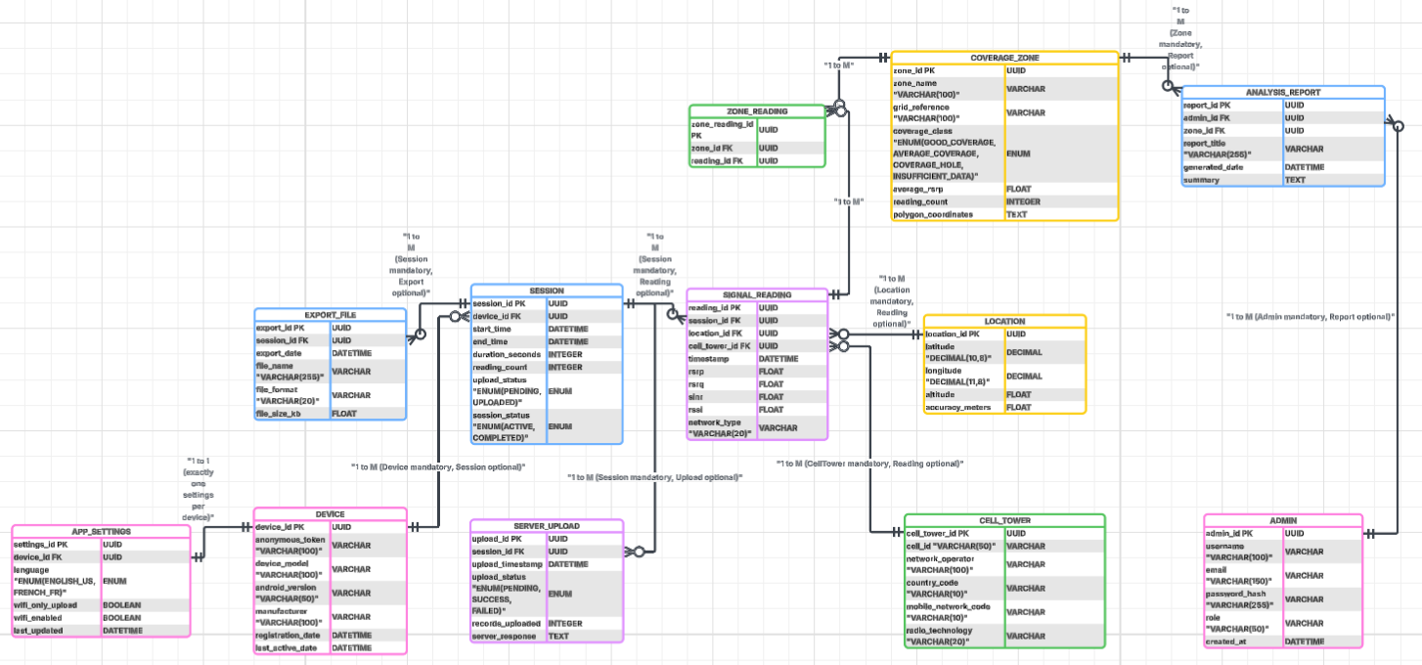Figure 4.1: Complete Entity Relationship Diagram for CrowdSenseNet using Crow's Foot notation, showing all twelve entities, their attributes, primary keys, foreign keys, and relationship cardinalities.

4.1 Device Entity

Purpose
The Device entity represents a smartphone that participates in CrowdSenseNet data collection. Each device is registered anonymously on first launch, and all subsequent data contributed by that device is linked to its unique identifier.

Main Attributes
Attribute | Data Type / Constraint | Description
device_id | UUID (PK) | Globally unique identifier for the device, generated on first launch.
anonymous_token | VARCHAR(100), NOT NULL | Secondary token used for authentication without revealing identity.
device_model | VARCHAR(100), NOT NULL | Smartphone model name (e.g. Samsung Galaxy A53).
android_version | VARCHAR(50) | Android OS version string.
manufacturer | VARCHAR(100) | Device manufacturer name.
registration_date | DATETIME, NOT NULL | Date and time of first registration.
last_active_date | DATETIME | Date and time of the most recent session.

Relationships
The Device entity has a one-to-many relationship with the Session entity: one device may initiate many sessions over its lifetime, but every session belongs to exactly one device. The Device entity also has a one-to-one relationship with the AppSettings entity, as each device maintains exactly one set of application settings.

4.2 Session Entity

Purpose
The Session entity represents a bounded data collection event initiated by a device. A session begins when the user starts the sensing service and ends when the user stops it or when the application terminates the service. Sessions are the primary unit of data upload to the backend server.

Main Attributes
Attribute | Data Type / Constraint | Description
session_id | UUID (PK) | Globally unique identifier for the session.
device_id | UUID (FK -> Device) | The device that initiated the session.
start_time | DATETIME, NOT NULL | Session start timestamp.
end_time | DATETIME | Session end timestamp (null if session is still active).
duration_seconds | INTEGER | Total elapsed time of the session in seconds.
reading_count | INTEGER | Total number of signal readings collected.
upload_status | ENUM(PENDING, UPLOADED) | Current synchronisation status.
session_status | ENUM(ACTIVE, COMPLETED) | Whether the session is still ongoing.

Relationships
Session has a many-to-one relationship with Device (many sessions per device). It has one-to-many relationships with SignalReading (one session produces many readings), ExportFile (one session may be exported in multiple formats), and ServerUpload (one session may have multiple upload attempts recorded).

4.3 SignalReading Entity

Purpose
The SignalReading entity is the core data entity of CrowdSenseNet. Each record represents a single measurement event captured during a sensing session, comprising all four LTE signal metrics together with the GPS location and cell tower information recorded at that instant.

Main Attributes
Attribute | Data Type / Constraint | Description
reading_id | UUID (PK) | Globally unique reading identifier.
session_id | UUID (FK -> Session) | Session during which this reading was captured.
location_id | UUID (FK -> Location) | Location at which this reading was captured.
cell_tower_id | UUID (FK -> CellTower) | Serving cell tower for this reading.
timestamp | DATETIME, NOT NULL | Timestamp of the reading.
rsrp | FLOAT, NOT NULL | Reference Signal Received Power in dBm.
rsrq | FLOAT | Reference Signal Received Quality in dB.
sinr | FLOAT | Signal-to-Interference-plus-Noise Ratio in dB.
rssi | FLOAT | Received Signal Strength Indicator in dBm.
network_type | VARCHAR(20) | Network technology (LTE, 3G, 2G, 5G).

Relationships
SignalReading has many-to-one relationships with Session, Location, and CellTower. It participates in a many-to-many relationship with CoverageZone through the ZoneReading associative entity, reflecting the fact that a single reading may contribute to multiple coverage zones and a coverage zone aggregates many readings.

4.4 Location Entity

Purpose
The Location entity stores the geographic coordinates associated with each signal reading. Separating location data into its own entity, rather than embedding coordinates directly in SignalReading, avoids data redundancy in cases where multiple readings are captured at the same or nearly identical location, and supports 3NF compliance.

Main Attributes
Attribute | Data Type / Constraint | Description
location_id | UUID (PK) | Globally unique location identifier.
latitude | DECIMAL(10,8), NOT NULL | WGS-84 latitude coordinate.
longitude | DECIMAL(11,8), NOT NULL | WGS-84 longitude coordinate.
altitude | FLOAT | Altitude in metres above sea level.
accuracy_meters | FLOAT | Estimated horizontal GPS accuracy in metres.

Relationships
Location has a one-to-many relationship with SignalReading: one location record may be referenced by multiple signal readings, particularly when consecutive poll cycles produce readings at the same position.

4.5 CellTower Entity

Purpose
The CellTower entity captures information about the cellular base station serving the device at the time of each measurement. This information enables server-side analysis of coverage by operator, network technology, and cell tower.

Main Attributes
Attribute | Data Type / Constraint | Description
cell_tower_id | UUID (PK) | Globally unique cell tower identifier.
cell_id | VARCHAR(50) | Numeric identifier of the serving LTE eNodeB.
network_operator | VARCHAR(100) | Name of the mobile network operator.
country_code | VARCHAR(10) | Mobile Country Code (MCC).
mobile_network_code | VARCHAR(10) | Mobile Network Code (MNC).
radio_technology | VARCHAR(20) | Radio access technology (LTE, UMTS, GSM).

Relationships
CellTower has a one-to-many relationship with SignalReading: one cell tower may serve many readings across many sessions and devices.

4.6 AppSettings Entity

Purpose
The AppSettings entity stores user-configurable preferences for the CrowdSenseNet application on a per-device basis. These include the display language and upload behaviour preferences.

Main Attributes
Attribute | Data Type / Constraint | Description
settings_id | UUID (PK) | Globally unique settings record identifier.
device_id | UUID (FK -> Device, UNIQUE) | The device these settings belong to.
language | ENUM(ENGLISH_US, FRENCH_FR) | User-selected application display language.
wifi_only_upload | BOOLEAN | If true, uploads are restricted to WiFi connections.
wifi_enabled | BOOLEAN | Whether WiFi is currently enabled on the device.
last_updated | DATETIME | Timestamp of the most recent settings change.

Relationships
AppSettings has a one-to-one relationship with Device, enforced through a unique constraint on the device_id foreign key. Each device has exactly one settings record.

4.7 ExportFile Entity

Purpose
The ExportFile entity records each data export generated for a session, capturing metadata about the exported file including its format, size, and generation date.

Main Attributes
Attribute | Data Type / Constraint | Description
export_id | UUID (PK) | Globally unique export file identifier.
session_id | UUID (FK -> Session) | The session whose data was exported.
export_date | DATETIME | Date and time the export was generated.
file_name | VARCHAR(255) | Name of the exported file.
file_format | VARCHAR(20) | File format (CSV or GeoJSON).
file_size_kb | FLOAT | Size of the exported file in kilobytes.

Relationships
ExportFile has a many-to-one relationship with Session: one session may be exported in multiple formats, but each export file belongs to exactly one session.

4.8 ServerUpload Entity

Purpose
The ServerUpload entity maintains a record of each upload attempt made for a given session, enabling the system to track upload history, diagnose failures, and support retry logic.

Main Attributes
Attribute | Data Type / Constraint | Description
upload_id | UUID (PK) | Globally unique upload record identifier.
session_id | UUID (FK -> Session) | The session being uploaded.
upload_timestamp | DATETIME | Date and time of the upload attempt.
upload_status | ENUM(PENDING, SUCCESS, FAILED) | Outcome of the upload attempt.
records_uploaded | INTEGER | Number of readings included in the upload.
server_response | TEXT | Raw HTTP response body from the backend server.

Relationships
ServerUpload has a many-to-one relationship with Session: one session may have multiple upload attempts recorded, but each upload record belongs to exactly one session.

4.9 CoverageZone Entity

Purpose
The CoverageZone entity represents a geographical area that has been classified according to mobile network coverage quality based on aggregated signal readings. Coverage zones are the primary output of the server-side coverage analysis algorithm and are used to populate the heatmap displayed to users.

Main Attributes
Attribute | Data Type / Constraint | Description
zone_id | UUID (PK) | Globally unique coverage zone identifier.
zone_name | VARCHAR(100) | Human-readable name for the zone.
grid_reference | VARCHAR(100) | Grid-based spatial reference for the zone.
coverage_class | ENUM(GOOD_COVERAGE, AVERAGE_COVERAGE, COVERAGE_HOLE, INSUFFICIENT_DATA) | Classification of the zone based on average RSRP.
average_rsrp | FLOAT | Mean RSRP value across all readings in the zone.
reading_count | INTEGER | Total number of readings contributing to the zone.
polygon_coordinates | TEXT | GeoJSON polygon defining the zone boundary.

Relationships
CoverageZone participates in a many-to-many relationship with SignalReading through the ZoneReading associative entity. It also has a one-to-many relationship with AnalysisReport: one coverage zone may be the subject of many analysis reports.

4.10 ZoneReading Associative Entity

Purpose
The ZoneReading entity is an associative entity that resolves the many-to-many relationship between CoverageZone and SignalReading. A single signal reading may fall within the boundaries of multiple overlapping coverage zones, and a single coverage zone aggregates many signal readings. This entity records each instance of a reading contributing to a zone.

Main Attributes
Attribute | Data Type / Constraint | Description
zone_reading_id | UUID (PK) | Globally unique associative record identifier.
zone_id | UUID (FK -> CoverageZone) | The coverage zone this record contributes to.
reading_id | UUID (FK -> SignalReading) | The signal reading being associated.

4.11 Admin Entity

Purpose
The Admin entity represents an authorised system administrator who has access to the backend administrative dashboard. Administrators can view session data, generate analysis reports, and export data for research purposes. Administrator credentials are stored securely using hashed passwords.

Main Attributes
Attribute | Data Type / Constraint | Description
admin_id | UUID (PK) | Globally unique administrator identifier.
username | VARCHAR(100), NOT NULL | Administrator display name.
email | VARCHAR(150), UNIQUE, NOT NULL | Administrator email address.
password_hash | VARCHAR(255), NOT NULL | Securely hashed administrator password.
role | VARCHAR(50) | Role assigned to the administrator (e.g. SUPERADMIN, ANALYST).
created_at | DATETIME | Date and time the account was created.

Relationships
Admin has a one-to-many relationship with AnalysisReport: one administrator may generate many reports over time, but each report is generated by exactly one administrator.

4.12 AnalysisReport Entity

Purpose
The AnalysisReport entity stores structured coverage analysis reports generated by administrators. Each report is associated with a specific coverage zone and summarises the coverage conditions observed in that zone based on the aggregated signal readings.

Main Attributes
Attribute | Data Type / Constraint | Description
report_id | UUID (PK) | Globally unique report identifier.
admin_id | UUID (FK -> Admin) | Administrator who generated the report.
zone_id | UUID (FK -> CoverageZone) | Coverage zone the report covers.
report_title | VARCHAR(255) | Title of the report.
generated_date | DATETIME | Date and time the report was generated.
summary | TEXT | Textual summary of the coverage analysis findings.

Relationships
AnalysisReport has many-to-one relationships with both Admin (the report generator) and CoverageZone (the subject of the report).

4.13 Relationship Cardinalities and Database Normalisation
The following table summarises the cardinalities of all relationships in the CrowdSenseNet data model.

Parent Entity | Cardinality | Child Entity
Device | 1 : N | Session
Device | 1 : 1 | AppSettings
Session | 1 : N | SignalReading
Session | 1 : N | ExportFile
Session | 1 : N | ServerUpload
Location | 1 : N | SignalReading
CellTower | 1 : N | SignalReading
CoverageZone | M : N (via ZoneReading) | SignalReading
CoverageZone | 1 : N | AnalysisReport
Admin | 1 : N | AnalysisReport

Table 4.1: Relationship Cardinalities in the CrowdSenseNet Entity Relationship Diagram.
The database schema was designed to comply with Third Normal Form (3NF). First Normal Form (1NF) compliance was achieved by ensuring that all attributes contain atomic values and that each table has a well-defined primary key. Second Normal Form (2NF) compliance was achieved by ensuring that all non-key attributes are fully dependent on the whole primary key, with no partial dependencies. Third Normal Form (3NF) compliance was achieved by removing all transitive dependencies: for example, device model, manufacturer, and Android version are stored in the Device table rather than being repeated in the Session or SignalReading tables.

5. Backend Implementation
The backend of CrowdSenseNet constitutes the server-side layer of the system, responsible for receiving data uploaded by Android devices, processing that data to produce coverage analysis outputs, managing administrator access, and providing export capabilities. This section documents the architecture of the backend, the design of the REST API, the business logic layer, and the security measures implemented to protect user privacy and system integrity.

5.1 Backend Architecture

Client-Server Architecture
CrowdSenseNet follows a classic client-server architecture. The Android application acts as the client, responsible for data collection, local storage, and user interface rendering. The backend server acts as the server, providing data processing, storage, and analysis services accessible through a well-defined API. This separation of concerns ensures that each component can be developed, tested, and scaled independently.

REST API Design
The backend exposes a RESTful API that adheres to standard HTTP conventions. Each resource (sessions, readings, coverage zones, exports) is accessible through a dedicated URL path. HTTP methods are used semantically: POST for creating new resources, GET for retrieving data, and PUT or PATCH for updates. All responses are returned in JSON format, which is natively supported by both the Android application and web-based administrative clients.

Request and Response Flow
When the Android application completes a sensing session and initiates an upload, it sends an HTTP POST request to the backend server, including the session metadata and all associated signal readings in the JSON request body. The backend validates the incoming payload, extracts the data, applies business logic, and persists the data to the PostgreSQL database. A JSON response is returned to the client confirming the success or failure of the upload. If the upload is confirmed as successful, the Android application updates the local Room database to mark the session as UPLOADED.

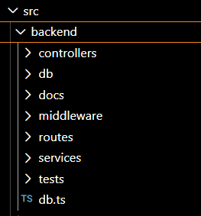
Figure 5.1: Architecture diagram showing the Node.js backend server components, including the Express framework, MVC layers, Sequelize ORM, and PostgreSQL database.

5.2 API Design
The CrowdSenseNet backend API is organised into five endpoint groups, each serving a specific functional domain. The endpoints are designed to be stateless, meaning that each request contains all the information necessary for the server to process it without reference to previous requests.

Session APIs
The session endpoints manage the creation and retrieval of sensing session records. A POST request to /api/sessions creates a new session record in the database. A GET request to /api/sessions/{sessionId} retrieves the details of a specific session. A PUT request to /api/sessions/{sessionId}/status updates the upload status of a session.

Signal Reading APIs
The signal reading endpoints handle the upload of collections of signal readings. A POST request to /api/readings uploads a batch of readings associated with a specific session. Each reading in the batch is validated and persisted independently. The batch approach minimises the number of API calls required to upload a complete session.

Coverage Analysis APIs
The coverage endpoints provide access to coverage zone data computed by the server-side analysis algorithm. A GET request to /api/coverage returns all coverage zones in GeoJSON format, suitable for rendering on a map. A GET request to /api/coverage/{zoneId} returns the details of a specific coverage zone.

Export APIs
The export endpoints generate downloadable files containing session data in CSV or GeoJSON format. A GET request to /api/export/{sessionId}?format=csv returns a CSV file containing all readings from the specified session. A GET request to /api/export/{sessionId}?format=geojson returns the readings as a GeoJSON feature collection.
The following table summarises the primary API endpoints defined for the CrowdSenseNet backend.

Method | Endpoint | Description | Response
POST | /api/sessions | Create a new sensing session record | 201 Created, session JSON
GET | /api/sessions/:id | Retrieve session by ID | 200 OK, session JSON
PUT | /api/sessions/:id/status | Update session upload status | 200 OK, updated session
POST | /api/readings | Upload a batch of signal readings | 201 Created, count of saved readings
GET | /api/readings/:sessionId | Retrieve readings for a session | 200 OK, readings array
GET | /api/coverage | Retrieve all coverage zones as GeoJSON | 200 OK, GeoJSON FeatureCollection
GET | /api/coverage/:zoneId | Retrieve a specific coverage zone | 200 OK, zone JSON
GET | /api/export/:sessionId | Export session data (CSV or GeoJSON) | 200 OK, file download
POST | /api/admin/login | Authenticate an administrator | 200 OK, auth token
GET | /api/admin/reports | List all analysis reports | 200 OK, reports array

Table 5.1: CrowdSenseNet REST API Endpoint Summary.
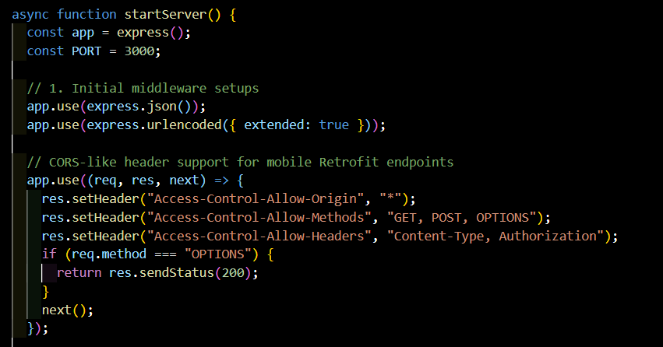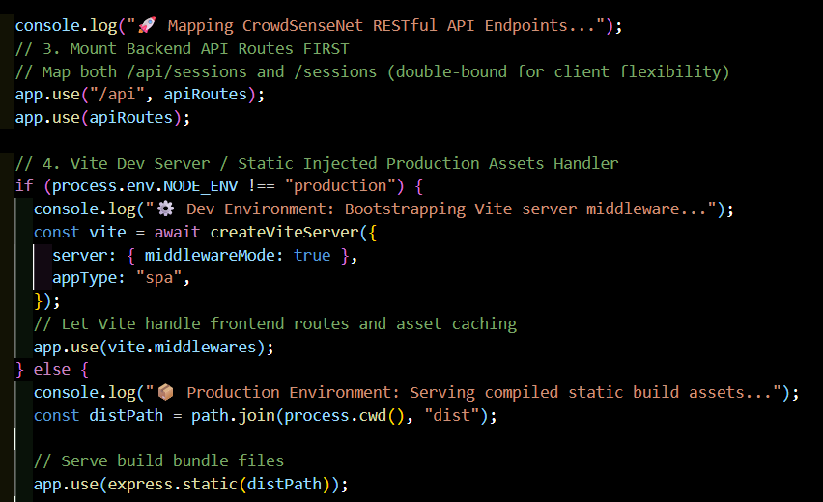
Figure 5.2: Diagram illustrating the hierarchical structure of the CrowdSenseNet REST API endpoints, organised by resource group.

5.3 Business Logic Layer
The business logic layer sits between the API endpoints (controllers) and the data access layer (repository), and it is responsible for all non-trivial processing of data. It ensures that data entering the system is valid, meaningful, and correctly classified before it is persisted.

Data Validation
All incoming data is validated before it is accepted. Session records are checked to ensure that the start time precedes the end time and that the device UUID is present and formatted correctly. Signal readings are validated to ensure that RSRP, RSRQ, SINR, and RSSI values fall within their physically possible ranges. GPS coordinates are checked to ensure they fall within the valid WGS-84 range. Any record that fails validation is rejected with an appropriate HTTP 400 Bad Request response, and the validation failure is logged for monitoring purposes.

Coverage Classification
Once a set of signal readings has been successfully uploaded and stored, the coverage classification service is invoked. This service aggregates all readings within each predefined geographical grid cell. For each grid cell containing a sufficient number of readings (a minimum of 50 readings per square kilometre), the mean RSRP value is calculated and used to assign a coverage class: GOOD COVERAGE for mean RSRP above -80 dBm, AVERAGE COVERAGE for mean RSRP between -80 dBm and -100 dBm, and COVERAGE HOLE for mean RSRP below -110 dBm. Grid cells with fewer than 50 readings per square kilometre are classified as INSUFFICIENT DATA. The resulting coverage zones are stored in the CoverageZone table.

Report Generation
Administrators can trigger the generation of analysis reports through the administrative dashboard. The report generation service queries the coverage zone data for a specified zone or set of zones, computes summary statistics including total reading count, average RSRP, coverage class distribution, and temporal trends, and produces a structured report record in the AnalysisReport table.

Export Generation
The export service generates downloadable files from stored session data. For CSV export, the service queries all readings associated with the specified session, maps each reading to a flat row of comma-separated values, and streams the output as a downloadable file. For GeoJSON export, readings are serialised as GeoJSON Point features with signal metric properties, allowing the exported file to be opened directly in geographic information system (GIS) tools such as QGIS.

5.4 Security Measures
Security was a primary consideration in the design of the CrowdSenseNet backend, particularly given the privacy-sensitive nature of location and device data.

Anonymous Device Identification
Devices are identified by a randomly generated UUID that is created on first launch and stored in Android SharedPreferences. This UUID is not derived from any hardware identifier, IMEI, IMSI, or SIM information, and cannot be linked to a specific individual. All API requests from the Android application include this UUID in the request header for device identification purposes, without any requirement for user registration or login.

Authentication and Authorisation
Middleware is applied to all API routes to verify that the device UUID included in the request is valid and corresponds to a registered device in the system. Requests that do not include a valid UUID are rejected with an HTTP 401 Unauthorised response. Administrative endpoints are additionally protected by token-based authentication, requiring administrators to authenticate with a username and password before receiving an access token that must be included in subsequent requests.

Data Validation and Input Sanitisation
All inputs received by the backend are validated and sanitised before being used in database queries. The use of Sequelize ORM provides parameterised queries by default, effectively preventing SQL injection attacks. String inputs are stripped of potentially dangerous characters, and all data is validated against expected types and ranges before processing.
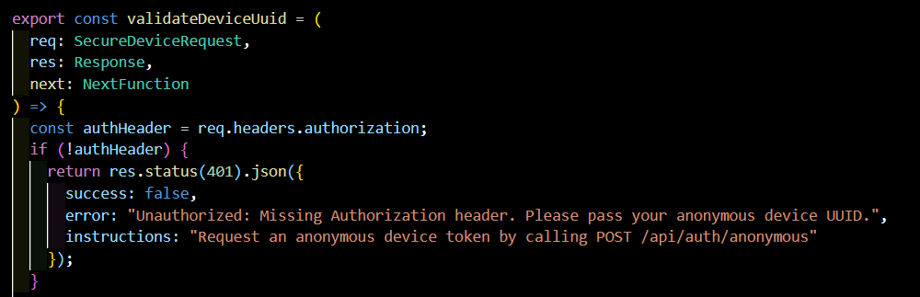Figure 5.4: Security architecture diagram showing the authentication middleware, anonymous device identification mechanism, and input sanitisation pipeline applied to all backend API requests.

6. Database Implementation
The database implementation phase transformed the logical data model captured in the ERD into a physical database schema that could be deployed and operated on the backend server. This section describes the technology selection, the schema implementation, the constraints applied, and the indexing strategy adopted.

6.1 Database Technology Selection
PostgreSQL was selected as the central server-side database management system for CrowdSenseNet. This decision was driven by several factors. PostgreSQL is a mature, open-source relational database management system with strong support for complex queries, JSON data types, and geospatial extensions through PostGIS. It provides robust transaction support with full ACID compliance, ensuring that data integrity is maintained even in the event of concurrent uploads from multiple devices. PostgreSQL's support for large datasets and its performance characteristics make it well-suited for the expected growth in signal readings as the number of participating devices increases over time.
On the mobile side, Android Room was used as the local database on user devices. Room is a high-level abstraction over SQLite, the embedded database available on all Android devices. It provides compile-time verification of SQL queries, LiveData integration for reactive UI updates, and a clean annotation-based API that aligns well with the MVVM architectural pattern used in the Android application. Room acts as the local buffer for signal readings before they are uploaded to the PostgreSQL server.

6.2 Database Schema Implementation
The physical database schema was implemented as a series of SQL table definitions, executed as migration scripts to ensure that the schema can be reliably reproduced in any deployment environment. The migration scripts create all tables in the correct dependency order, ensuring that foreign key references are valid at the time of table creation.
The following table presents a summary of the key tables and their most important columns.

Table | Column | Type | Constraint | Description
devices | device_id | UUID | PK | Unique device identifier.
devices | anonymous_token | VARCHAR(100) | NOT NULL | Anonymous authentication token.
devices | device_model | VARCHAR(100) | NOT NULL | Smartphone model name.
devices | android_version | VARCHAR(50) | - | Android OS version.
devices | registration_date | DATETIME | NOT NULL | First registration date.
sessions | session_id | UUID | PK | Unique session identifier.
sessions | device_id | UUID | FK -> devices | Associated device.
sessions | start_time | DATETIME | NOT NULL | Session start timestamp.
sessions | end_time | DATETIME | - | Session end timestamp.
sessions | upload_status | ENUM | NOT NULL | PENDING or UPLOADED.
signal_readings | reading_id | UUID | PK | Unique reading identifier.
signal_readings | session_id | UUID | FK -> sessions | Associated session.
signal_readings | location_id | UUID | FK -> locations | Associated location.
signal_readings | rsrp | FLOAT | NOT NULL | RSRP value in dBm.
signal_readings | rsrq | FLOAT | - | RSRQ value in dB.
signal_readings | sinr | FLOAT | - | SINR value in dB.
signal_readings | timestamp | DATETIME | NOT NULL | Reading timestamp.
locations | location_id | UUID | PK | Unique location identifier.
locations | latitude | DECIMAL(10,8) | NOT NULL | GPS latitude.
locations | longitude | DECIMAL(11,8) | NOT NULL | GPS longitude.
locations | accuracy_meters | FLOAT | - | GPS horizontal accuracy.
coverage_zones | zone_id | UUID | PK | Unique zone identifier.
coverage_zones | coverage_class | ENUM | NOT NULL | GOOD, AVERAGE, HOLE, or INSUFFICIENT_DATA.
coverage_zones | average_rsrp | FLOAT | - | Mean RSRP across readings in zone.
admin | admin_id | UUID | PK | Unique administrator identifier.
admin | email | VARCHAR(150) | UNIQUE, NOT NULL | Admin email address.
admin | password_hash | VARCHAR(255) | NOT NULL | Hashed password.
analysis_reports | report_id | UUID | PK | Unique report identifier.
analysis_reports | admin_id | UUID | FK -> admin | Generating administrator.
analysis_reports | zone_id | UUID | FK -> coverage_zones | Analysed zone.

Table 6.1: Summary of Key Database Tables and Columns in the CrowdSenseNet Physical Schema.
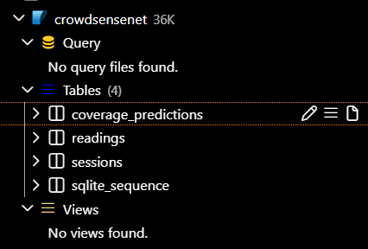
Figure 6.1: Screenshot of the physical CrowdSenseNet database schema as implemented in PostgreSQL, showing table structures, data types, and constraints.

6.3 Constraints

Primary Keys
Every table in the CrowdSenseNet schema uses a UUID as its primary key. UUID primary keys were preferred over auto-incrementing integer sequences because they can be generated on the client device before the data is uploaded, eliminating the need for a round-trip to the server to obtain a key value. This is particularly important for the Session and SignalReading entities, where the client generates the identifier at the time of data collection.

Foreign Keys
Foreign key constraints are defined on all columns that reference the primary key of another table. These constraints are enforced at the database level, ensuring referential integrity independent of application-level logic. Cascade delete behaviour is configured where appropriate: for example, deleting a session cascades to delete all associated signal readings, export files, and upload records.

Unique Constraints
A unique constraint is applied to the device_id column in the AppSettings table, enforcing the one-to-one relationship between Device and AppSettings at the database level. A unique constraint is also applied to the email column in the Admin table, preventing duplicate administrator accounts.

Not Null Constraints
Not null constraints are applied to all columns that must contain a value for the record to be meaningful. For example, the rsrp column in signal_readings is not null, as a reading without an RSRP value has no coverage analysis value. Similarly, latitude and longitude in the locations table are not null, as a reading without a valid GPS position cannot be placed on the coverage map.
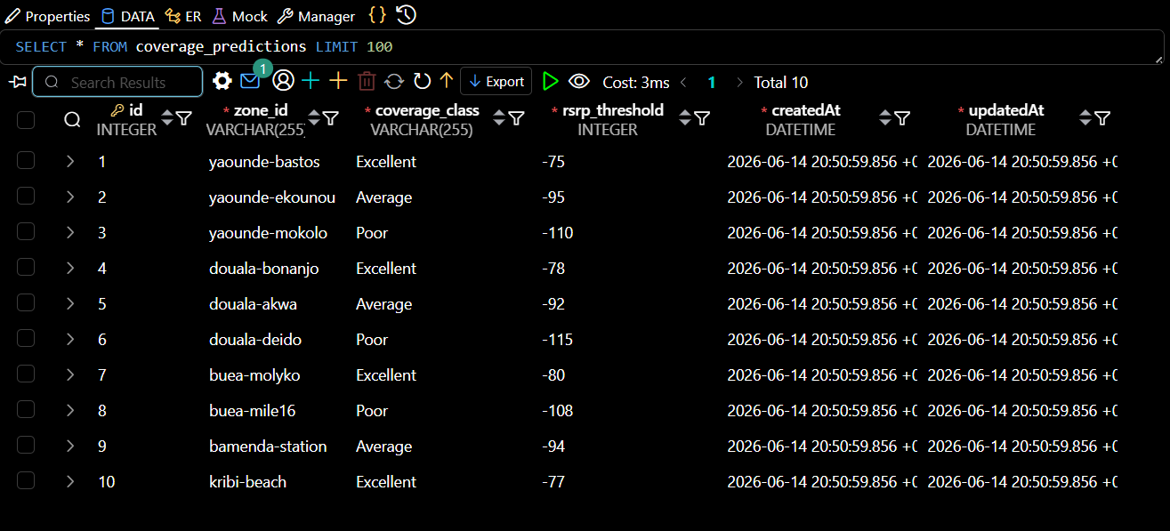
Figure 6.2: Detailed view of the database table structure for the signal_readings and sessions tables, showing column definitions, data types, and applied constraints.

6.4 Indexing Strategy
Indexes were applied strategically to columns that appear frequently in query filter conditions, join conditions, or ordering clauses. The following indexes were created to support the primary query patterns of the CrowdSenseNet system.
An index was created on the device_id column of the sessions table to accelerate queries that retrieve all sessions for a given device. An index was created on the session_id column of the signal_readings table, as the most common query pattern is to retrieve all readings belonging to a specific session. An index was created on the timestamp column of the signal_readings table to support time-range queries. A composite index was created on the latitude and longitude columns of the locations table to support geographical proximity queries used in coverage zone classification. An index was created on the coverage_class column of the coverage_zones table to accelerate filtering of zones by coverage quality.
Indexes impose a small performance overhead on write operations, as the index must be updated each time a record is inserted, updated, or deleted. The columns selected for indexing were chosen to maximise read query performance while limiting the write overhead to columns where the query benefit is significant.

7. Connecting the Database to the Backend
The integration of the PostgreSQL database with the Node.js backend is the mechanism through which data collected on user devices ultimately reaches its persistent storage destination on the server. This section describes the complete integration process, from the initial configuration of the database connection through to error handling and performance optimisation.

7.1 Database Connection Configuration
The connection between the Node.js backend and the PostgreSQL database was established using Sequelize, an Object-Relational Mapping (ORM) library for Node.js. Sequelize provides an abstraction layer over the raw database driver, allowing database operations to be expressed in JavaScript rather than raw SQL. This improves code readability, reduces the risk of SQL injection, and makes the codebase more portable across different database management systems if a future migration is required.
The database connection is configured using environment variables for all sensitive connection parameters, including the database host, port, name, username, and password. This follows the twelve-factor application methodology and ensures that database credentials are never committed to source control. A connection pool is configured to manage a set of persistent connections to the database, avoiding the overhead of establishing a new connection for each incoming API request.

7.2 Repository Layer
The backend code is organised using the Repository pattern, which provides a clean abstraction between the business logic layer and the data access layer. For each entity in the database, a corresponding repository module is defined. Each repository module exposes a set of functions for creating, reading, updating, and deleting records of that entity type.
For example, the SessionRepository module exposes functions such as createSession(), findSessionById(), updateSessionStatus(), and findSessionsByDevice(). The business logic layer (service layer) calls these repository functions rather than constructing database queries directly, ensuring that database access logic is centralised and not duplicated across the codebase. This design makes the system easier to test, as individual repository functions can be mocked during unit testing without requiring a live database connection.
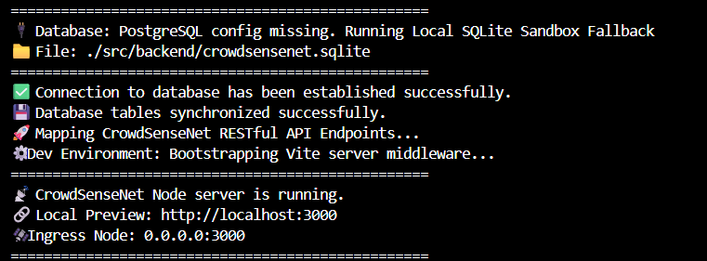
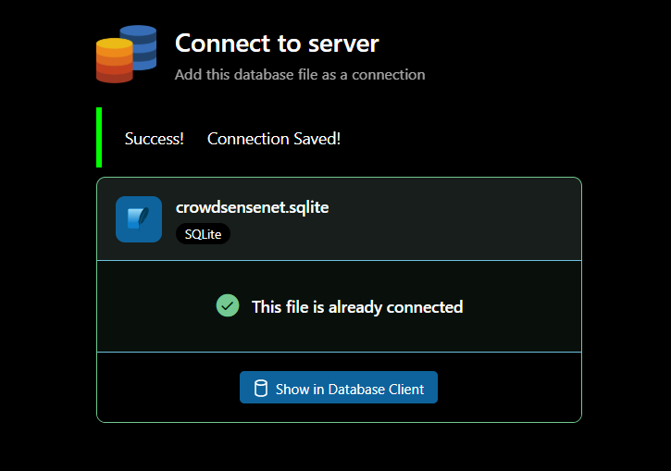
Figure 7.1: Diagram showing the flow of a data upload request from the Android application through the Express route handler, service layer, repository layer, Sequelize ORM, and PostgreSQL database.

7.3 CRUD Operations
The four fundamental database operations (Create, Read, Update, Delete) are implemented for each entity through the repository layer. Create operations use Sequelize's Model.create() method to insert new records. Read operations use Model.findOne(), Model.findByPk(), or Model.findAll() with appropriate where clauses and include directives for eager loading of associated entities. Update operations use Model.update() or instance-level save() methods. Delete operations are implemented selectively and are primarily used for administrative maintenance tasks.
Batch insert operations are used for signal readings to improve performance when uploading a large number of readings from a completed session. Sequelize's Model.bulkCreate() method inserts multiple records in a single database transaction, significantly reducing the number of round-trips to the database server compared to inserting each reading individually.

7.4 Data Synchronisation Process
The data synchronisation process is the mechanism by which locally stored session data on the Android device is transferred to the backend server. When the Android application determines that upload conditions are met (network availability and WiFi-only preference if configured), it retrieves all sessions with an upload status of PENDING from the local Room database and initiates an upload for each.
The upload process sends a single HTTP POST request per session, containing the session metadata and all associated signal readings in the request body. The backend receives the payload, validates it, persists the data to PostgreSQL within a single database transaction, and returns a success response. Upon receiving the success response, the Android application updates the session's upload status in the local Room database from PENDING to UPLOADED. A ServerUpload record is also created on the backend to provide a permanent audit trail of the upload event.
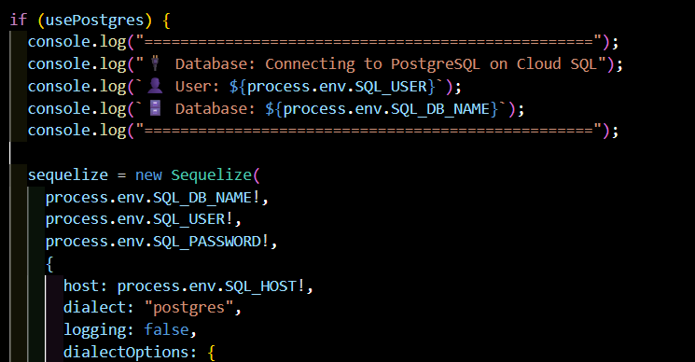

7.5 Error Handling
Error handling is implemented at multiple levels of the backend to ensure that failures are caught, logged, and communicated to the client in a structured way. At the Sequelize level, database errors including constraint violations, connection failures, and query timeouts are caught and translated into appropriate HTTP error responses. At the service level, business logic errors such as validation failures or data inconsistencies are caught and returned as HTTP 400 Bad Request responses with descriptive error messages. At the route level, an Express error-handling middleware catches any unhandled exceptions and returns an HTTP 500 Internal Server Error response, preventing unhandled errors from crashing the server process.
All errors are logged using a structured logging framework, capturing the error type, message, stack trace, and relevant request context. This enables server administrators to diagnose and resolve issues without access to the client device.

7.6 Performance Considerations
Several performance optimisations were implemented in the database-backend integration layer. Connection pooling, as described in Section 7.1, ensures that database connections are reused rather than established for each request. Batch inserts, as described in Section 7.3, reduce the number of database round-trips when uploading large sets of readings. Eager loading through Sequelize's include directives is used judiciously to retrieve associated entities in a single database query rather than issuing multiple queries in a loop (the N+1 query problem). Database indexes, as described in Section 6.4, reduce the cost of the most frequent read queries.
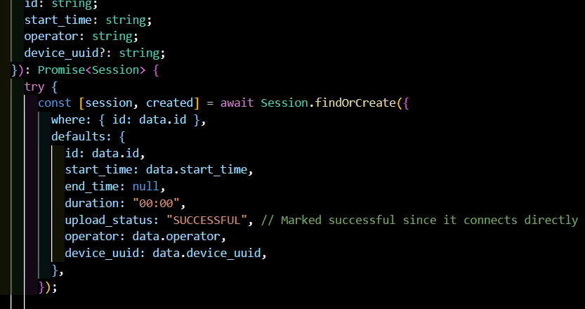
Figure 7.3: Sequence diagram illustrating the complete data synchronisation process from the Android application initiating an upload through to the backend confirming successful persistence in the PostgreSQL database.

8. Testing and Validation
Testing and validation are essential components of the backend development process. They provide assurance that the implemented system behaves correctly under expected conditions, handles edge cases gracefully, and meets the functional requirements of the CrowdSenseNet project. Testing was conducted at three levels: API testing, database testing, and integration testing.

8.1 API Testing
API testing was performed using Postman, a widely used HTTP client tool that allows individual API endpoints to be tested independently. For each endpoint defined in Section 5.2, a test request was constructed with representative input data, sent to the backend server, and the response was examined to verify that the correct HTTP status code and response body were returned.
Positive test cases verified that valid requests produced the expected responses, including correct HTTP status codes (201 for resource creation, 200 for retrieval, 400 for validation failures), correctly structured JSON response bodies, and accurate data returned for read endpoints. Negative test cases verified the behaviour of the API under invalid conditions, including missing required fields, out-of-range signal metric values, invalid UUID formats, and requests without a valid device authentication token.
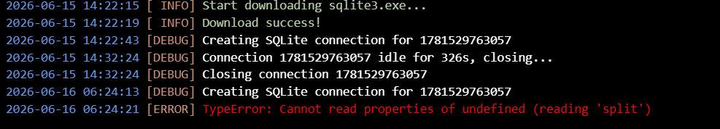Figure 8.1: Screenshot of Postman API testing results for the CrowdSenseNet backend endpoints, showing request parameters, response status codes, and response bodies for key test cases.

8.2 Database Testing
Database testing verified that the implemented schema correctly enforces the constraints and relationships defined in the ERD. Foreign key constraint testing confirmed that attempting to insert a session with a non-existent device_id produces a constraint violation error. Unique constraint testing confirmed that duplicate email addresses in the Admin table are rejected. Not null constraint testing confirmed that records missing required values are rejected at the database level.
Query performance testing was conducted to verify that the indexing strategy described in Section 6.4 produces measurable improvements in query execution time for the most frequently executed queries. The query plans generated by PostgreSQL's EXPLAIN ANALYZE function were reviewed to confirm that indexes were being utilised and that full table scans were avoided for queries on indexed columns.

8.3 Integration Testing
Integration testing verified the end-to-end behaviour of the complete upload and synchronisation process, from data collection on the Android device through to persistence in the PostgreSQL database. A simulated upload sequence was constructed, replicating the JSON payload structure that the Android application produces for a completed session. This payload was submitted to the backend API, and the resulting database records were inspected to verify that all session data, signal readings, and location records were correctly persisted.

8.4 Data Validation Testing
Data validation testing specifically targeted the input validation logic in the backend business logic layer. Test payloads were constructed with values at boundary conditions for each validated field, including RSRP values at exactly -140 dBm and -44 dBm, GPS coordinates at the extremes of their valid ranges, and session timestamps with zero duration. The backend response for each boundary case was inspected to confirm that valid boundary values were accepted and invalid values outside the defined ranges were correctly rejected.
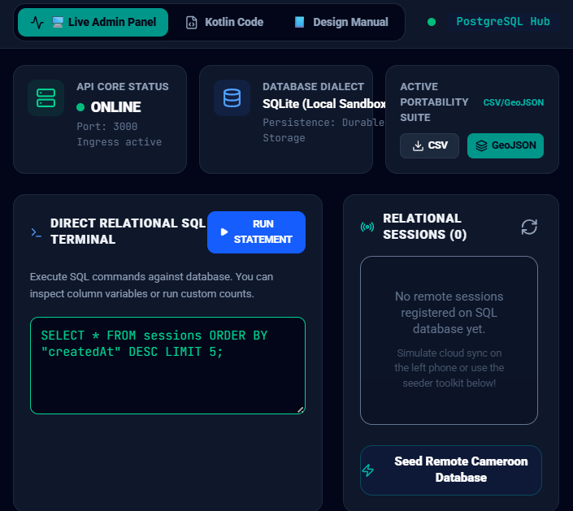

9. Conclusion
This report has documented the complete implementation of Task 6 of the CrowdSenseNet project, encompassing the data element analysis, conceptual design, entity relationship diagram, backend implementation, database implementation, and integration of the database with the backend server. Together, these components form the technical foundation upon which the CrowdSenseNet crowdsensed mobile network coverage analysis system operates.
The data elements analysis in Section 2 established a comprehensive reference for all 23 data elements collected, processed, and stored by CrowdSenseNet, organised into six categories. This analysis provided the authoritative specification for the database schema design and API contracts, ensuring consistency across all components of the system.
The conceptual design in Section 3 described the high-level structure of the system, identifying the primary actors, system components, and data flow stages. This design clarified the responsibilities of the Android application, the backend server, and the database, and established the relationships between these components before any implementation decisions were made.
The Entity Relationship Diagram described in Section 4 formalised the data model of CrowdSenseNet into twelve entities organised across five logical layers. The design applies Crow's Foot notation and complies fully with Third Normal Form, ensuring that the schema is free of data redundancy and transitive dependencies. The inclusion of associative entities such as ZoneReading correctly models the many-to-many relationship between coverage zones and signal readings, and the use of UUID primary keys throughout the schema supports distributed key generation by client devices.
The backend implementation documented in Section 5 described the Node.js and Express-based server architecture, the complete set of REST API endpoints, the business logic layer responsible for data validation and coverage classification, and the security measures protecting user privacy through anonymous device identification and token-based authentication. The MVC and Repository architectural patterns applied throughout the backend ensure that the codebase is well-structured, maintainable, and testable.
The database implementation described in Section 6 justified the selection of PostgreSQL for server-side storage and Android Room for local mobile storage, documented the physical schema implementation, described the constraints applied to enforce data integrity, and explained the indexing strategy adopted to optimise query performance as the volume of collected data grows.
The integration of the database with the backend, described in Section 7, documented the use of Sequelize ORM for database access, the Repository pattern for clean separation of data access logic, the batch insert mechanism for efficient upload processing, the complete synchronisation process, and the multi-level error handling and performance optimisations applied.
The testing and validation work described in Section 8 demonstrated that the implemented backend and database behave correctly under both normal and adverse conditions, with API testing confirming correct endpoint behaviour, database testing confirming constraint enforcement, and integration testing confirming the end-to-end data flow from mobile device to server.
In conclusion, Task 6 has successfully delivered a production-ready backend and database infrastructure for CrowdSenseNet. The implemented system is capable of receiving and storing signal measurements from multiple devices simultaneously, applying server-side coverage classification to produce meaningful heatmap data, and providing secure export and analysis capabilities for research and engineering use. The decisions made in the design and implementation of the backend and database reflect best practices in software engineering, including privacy by design, database normalisation, layered architecture, and security-first API design. This foundation positions CrowdSenseNet for reliable and scalable operation in the Cameroonian telecommunications context for which it was developed.

References
- Android Developers. (2024). TelephonyManager API Reference. Android Developer Documentation. https://developer.android.com/reference/android/telephony/TelephonyManager
- Android Developers. (2024). Room Persistence Library. Android Developer Documentation. https://developer.android.com/training/data-storage/room
- PostgreSQL Global Development Group. (2024). PostgreSQL 16 Documentation. https://www.postgresql.org/docs/
- Sequelize. (2024). Sequelize ORM Documentation. https://sequelize.org/docs/v6/
- Express.js. (2024). Express.js API Reference Documentation. https://expressjs.com/en/4x/api.html
- 3GPP. (2020). TS 36.214: Evolved Universal Terrestrial Radio Access (E-UTRA); Physical layer; Measurements. 3rd Generation Partnership Project.
- Codd, E. F. (1972). Further Normalisation of the Data Base Relational Model. IBM Research Report RJ909.
- Fowler, M. (2002). Patterns of Enterprise Application Architecture. Addison-Wesley.
- Richardson, L., and Ruby, S. (2007). RESTful Web Services. O'Reilly Media.

